Test Case 5

**Title:** Check filter Shopping Day

**Section:** Product Filter

**Preconditions:**

Open cite <https://rozetka.com.ua/ua/>

Choose category Gaming Laptop

On cite must be over 10+ gaming Laptop

**Steps**

1. On the left side of filter panel check the box On Sale

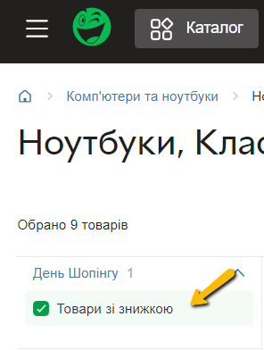

**Expected results:**

Selected filter Shopping Day - On Sale

Products mud be filtered

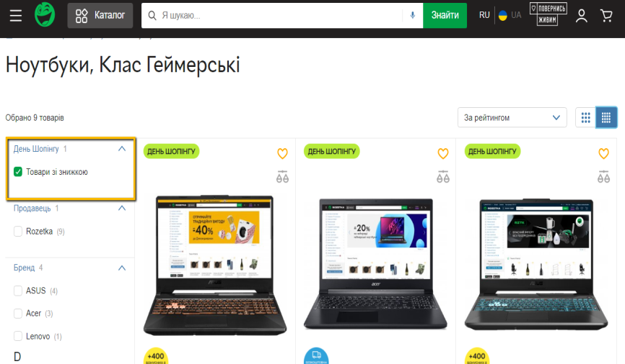

**Step 2**

Open first Laptop filtered by Shopping Day On Sale

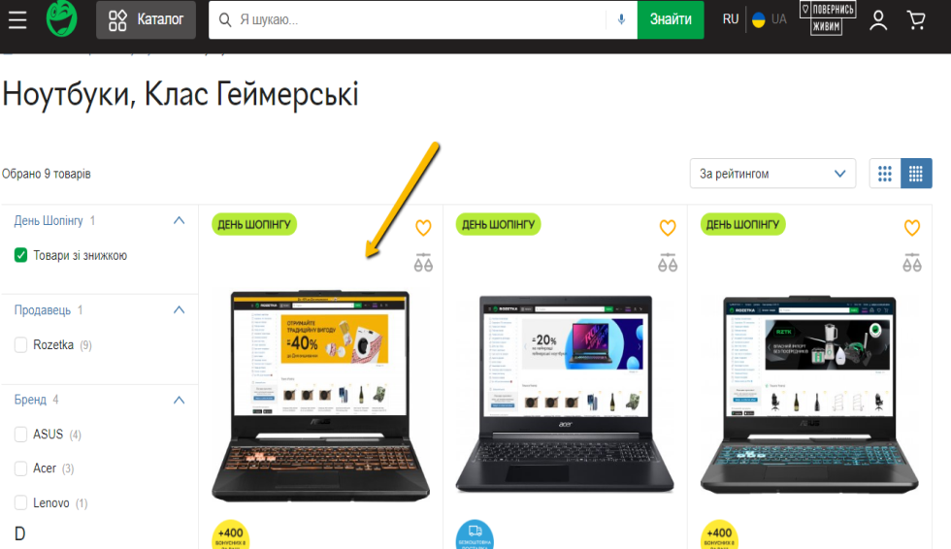

**Expected Results:**

Must be opening web-cite with description of laptop on sale

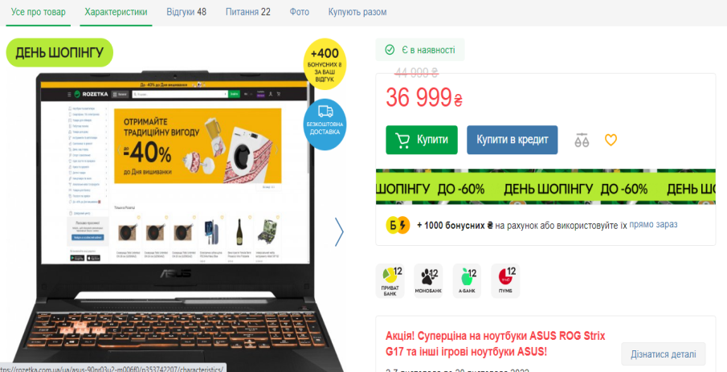

**Step 3**

Check the laptop is On sale

**Expected results:**

On the right side must be discounted amount of this Laptop

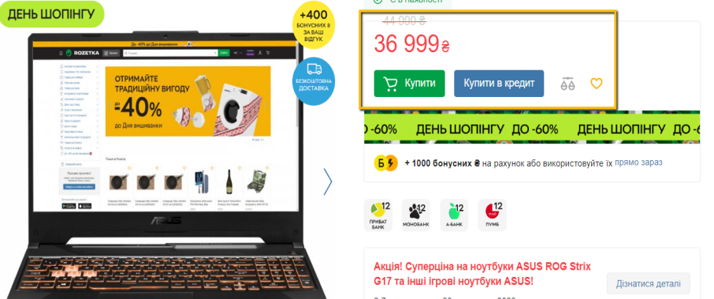

Priority: Medium